
CPISM
- Project
BAGBAG

SABA NAZ
(Student id: 1692465)
HAFSA
(Student id: 1691713)
DUAA
(Student id: 1690190)
NAFAE SHAH
(Student id: 1693484)
IRFAN
(Student id: 1653631)

Content
Abstract 1
Acknowledgement 2
Requirement 3
ScreenShot 4
Task Sheet 8

Abstract

This project, titled " BAG BAG Collection Website", aims to provide a modern, user-friendly online platform showcasing a curated range of luxury bags brands including Nike, puma Gucci, Prada, Coach, and Celine. The website is designed with an emphasis on clean UI/UX principles to enhance the browsing experience for users. It features dynamic brand-based filtering, stylish product cards, and a responsive layout that adapts seamlessly to different devices.
Built using HTML, CSS, and JavaScript, the project focuses on both aesthetics and functionality. Each brand's product data is managed using JavaScript objects, allowing for scalable and organized content management. The design not only reflects the elegance of high-end fashion but also ensures ease of navigation and interaction for the users.
This project demonstrates a practical application of frontend development skills and serves as a foundation for potential future integration with backend technologies and e-commerce features.

Acknowledgement:

I would like to express my sincere gratitude to Ms. Yasmeen Noor for her continuous support, guidance, and encouragement throughout the development of my project. Her valuable insights and feedback played a crucial role in the successful completion of this website.
I am also thankful to my institute, Aptech Metro Star Gate, for providing me with the opportunity and platform to work on this project titled “BAG BAG Collection Website”. This project not only enhanced my frontend development skills in HTML, CSS, and JavaScript, but also gave me a better understanding of UI/UX design.
The completion of this project would not have been possible without the support and motivation provided by my mentor and institute.

Requirements
Problem Statement
Bag Bag is an online store for various types of Bags. They have collection of bags. Now they want to revamp their website with all the products listed on the website. Consumers should find it easy to view various products and decide upon purchasing the right product to meet their requirements.
A website needs to be designed to display various bags available with the store. Details of locations, feedback must be included.

Requirement Specification:
The Web site is to be created based on the following requirements.
- The Home Page should be created making use of Sections with a suitable logo, the header section can be added which will show images of various Bags.
- The site must contain the links to navigate through various types of Bags, Backpack’s etc.
- Site should have different section for Men and Women and bags should be placed accordingly.
- Links of bags must be categorized like (Bags, Sling Bags, Backpack’s etc.)
- Specification and Pricing of Bags should be added along with the images.
- Website should provide section for various brands offered in the store.
- Gallery section should be added for viewing different images.
- Feedback must be allowed to enter by the viewer
- Site map, Gallery, about us, Queries link, contact us link must be added.
- The complete description must be allowed to get download as pdf or doc file.
- The advertise section with various facilities provided should be mentioned.

窗体顶端

窗体底端

Screenshots:

Home Page:

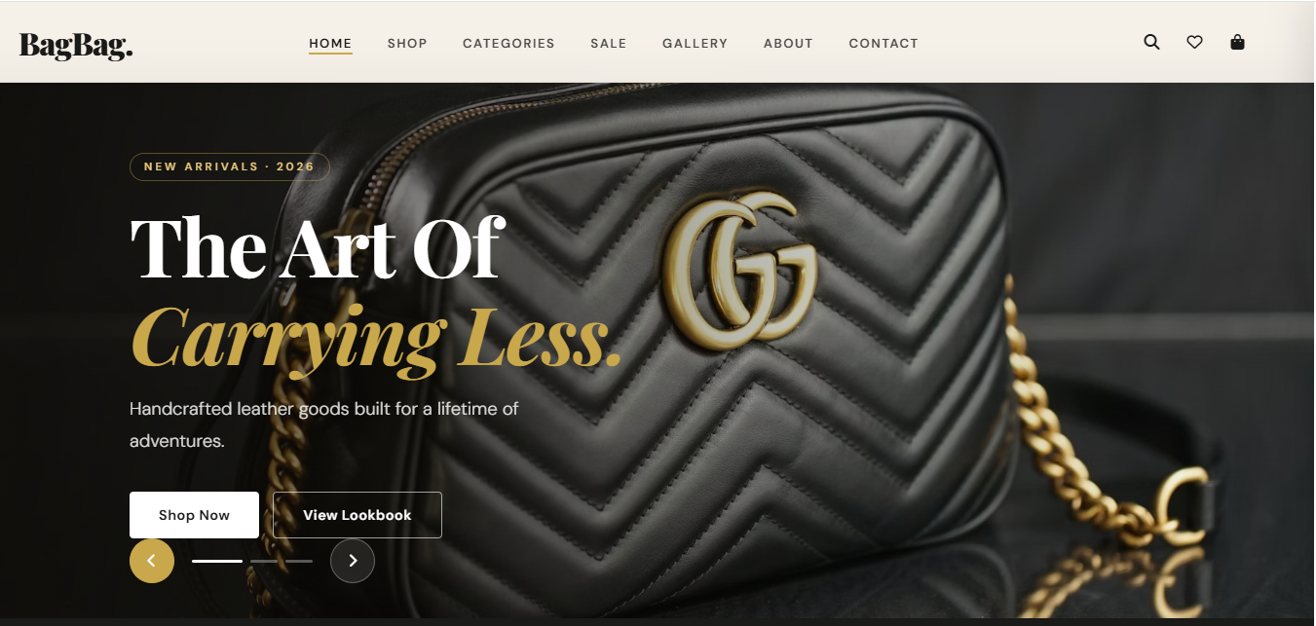

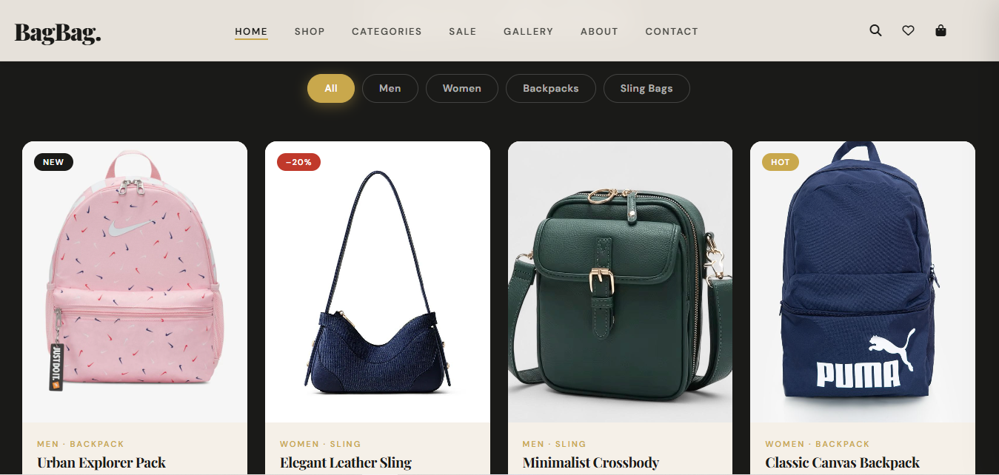

About Page:

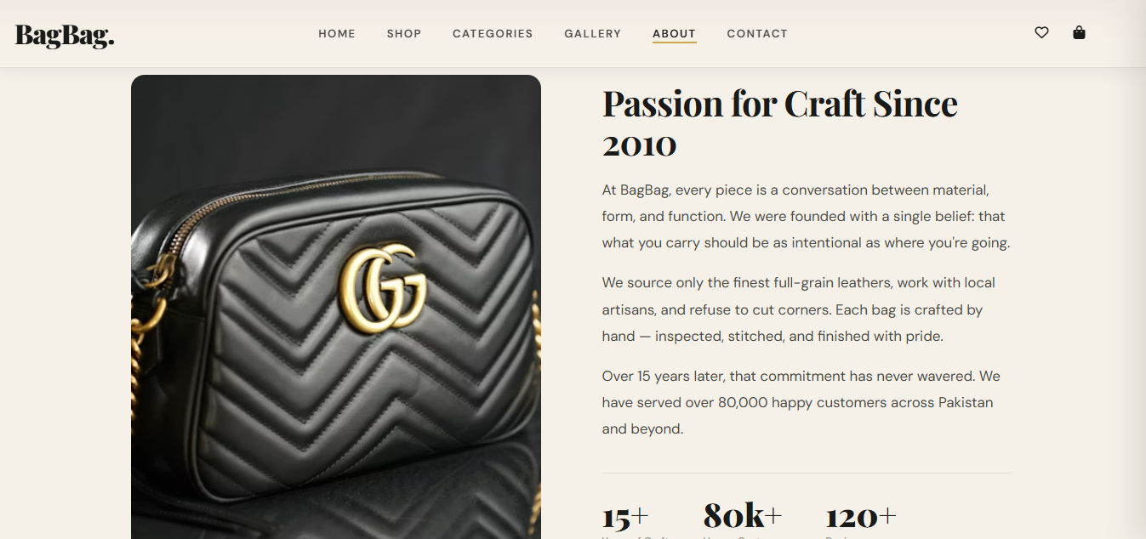

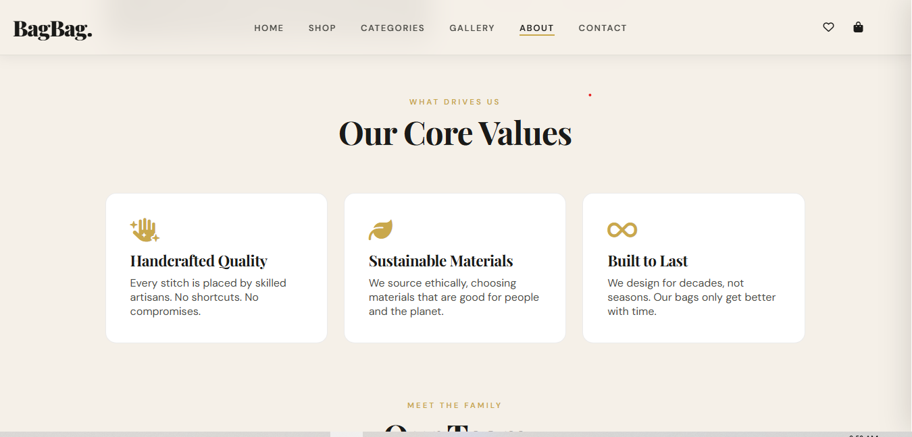

feedback Page:
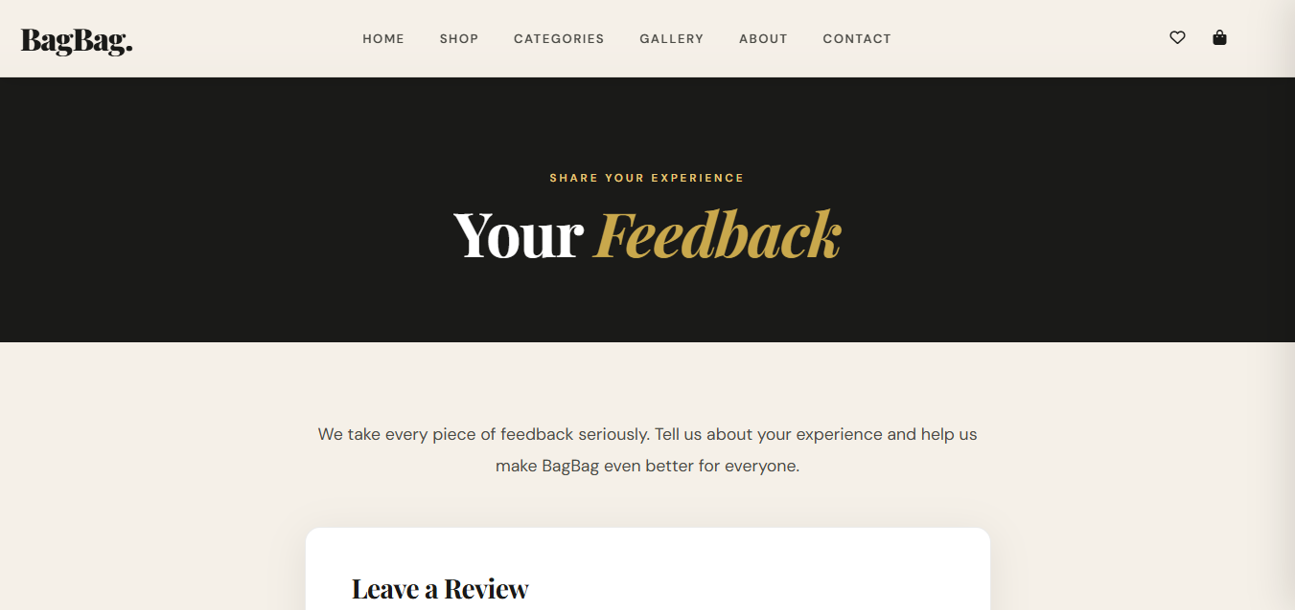

Site Map:

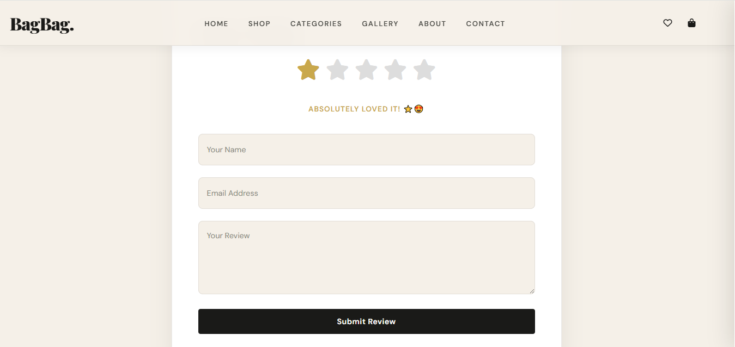

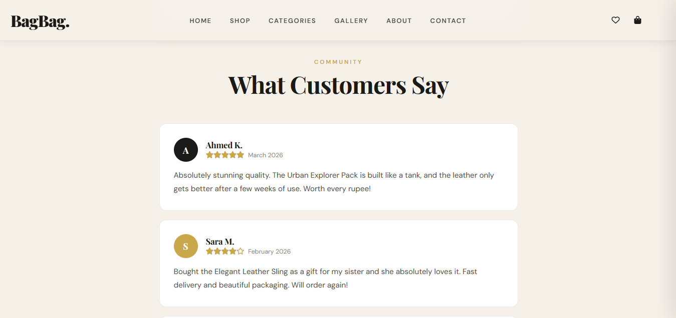

Gallery page:

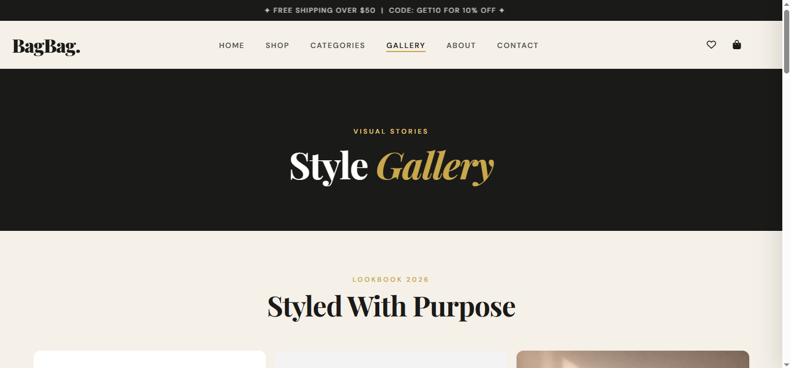

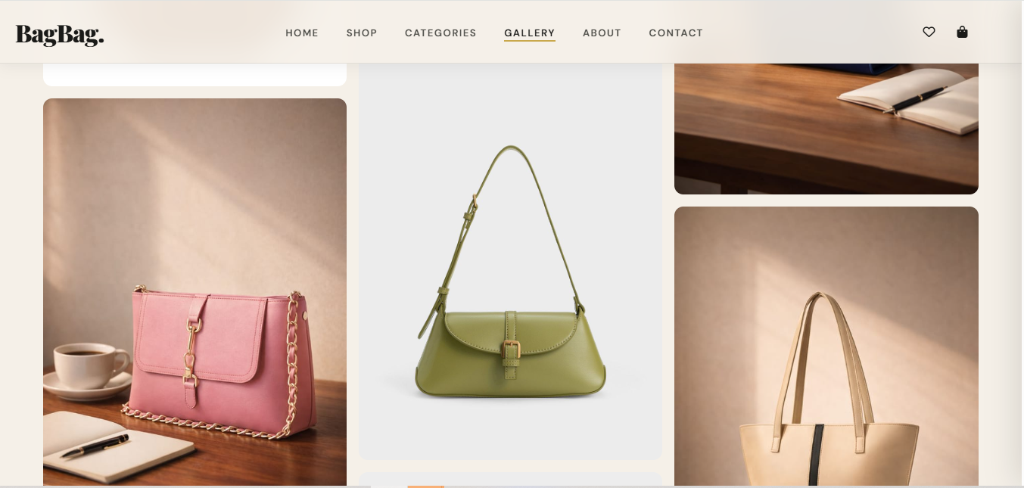

Contact Page:
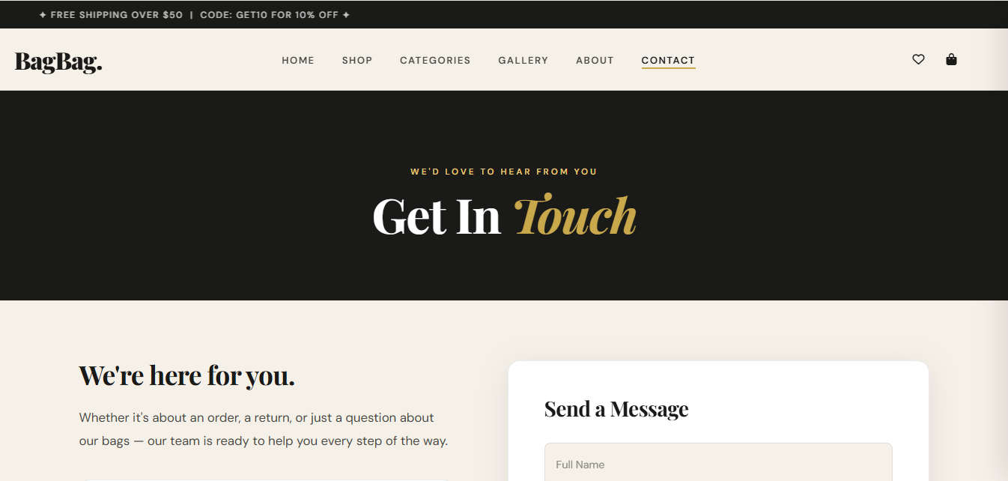

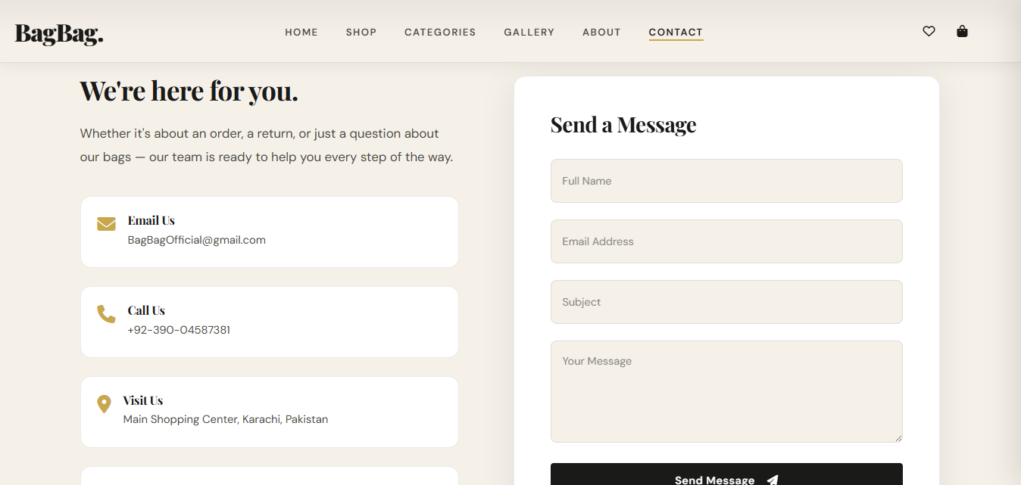

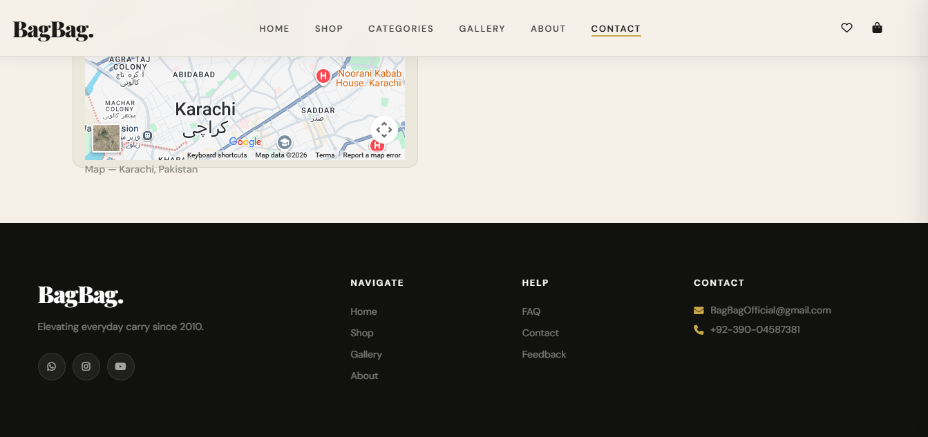

Task Sheet:

Task | Name | Days
Analyzing | Saba Naz | 02
Prototype | Saba Naz | 03
HTML Code | Saba Naz | 5
CSS Code | Saba Naz | 5
JAVASCRIPT | Saba Naz | 5


THANKYOU !

